Exploratory Data Analysis (EDA)
Documentation

- NAV trend analysis — plot daily NAV for all 40 schemes 2022–2026. Highlight 2023 bull run and 2024 market corrections using Plotly.
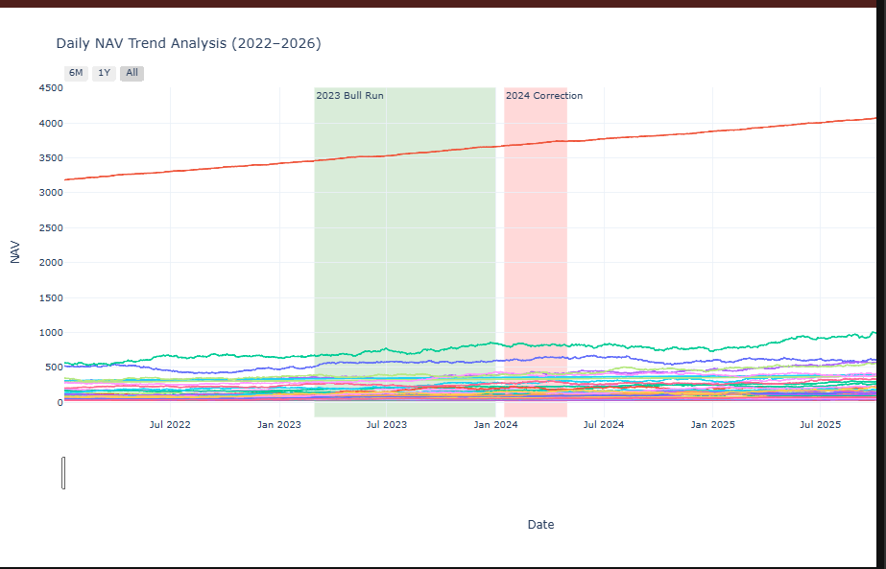
The graph highlights a steady rise in daily NAV values from 2022 to 2026, with a sharp bull run in 2023, a correction in 2024, and recovery afterward, reflecting overall long-term growth.
2.AUM growth bar chart — grouped bar by fund house for each year 2022–2025. Highlight SBI at ₹12.5L Cr dominance using Seaborn

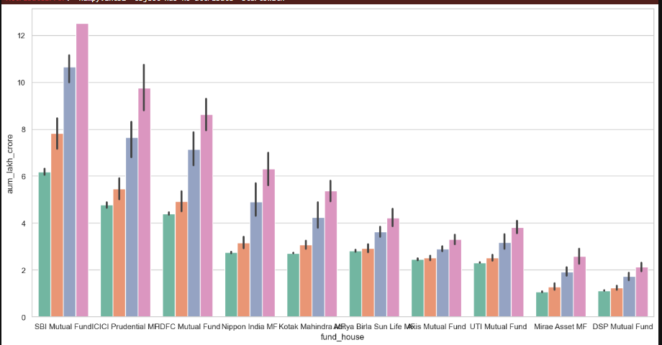
Several mutual funds exhibited temporary declines during 2024, indicating periods of market correction.

- SIP inflow time-series — monthly SIP trend Jan 2022 – Dec 2025. Annotate the ₹31,002 Cr all-time high (Dec 2025) using Plotly.

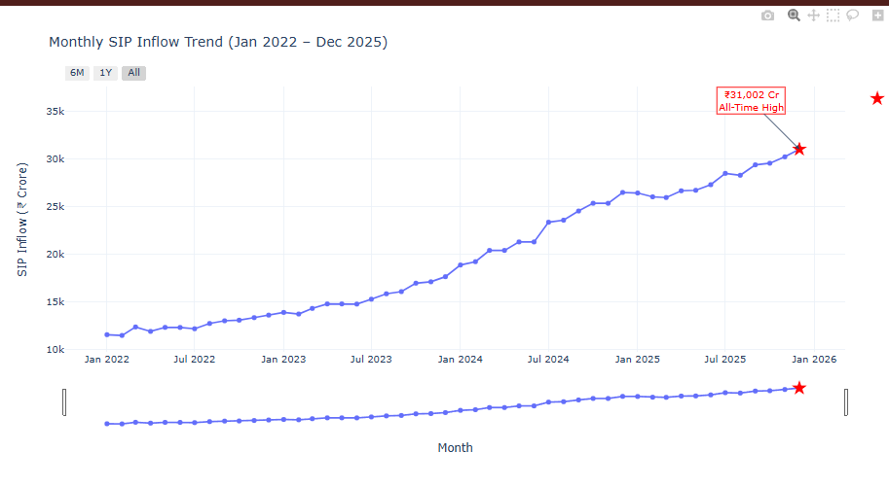
Monthly SIP inflows showed a consistent upward trend and reached a record ₹31,002 crore in December 2025.

4.Category inflow heatmap — months on X-axis, fund categories on Y-axis, net inflow as colour intensity using Seaborn.
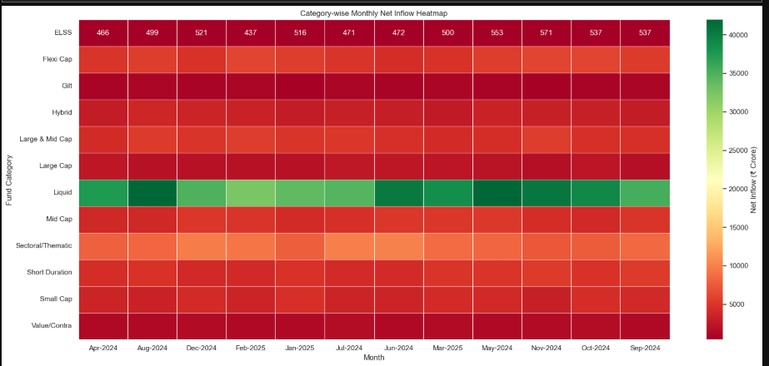
The number of mutual fund folios nearly doubled between January 2022 and December 2025, indicating rapid growth in investor participation.

5. Investor demographics — age group distribution pie chart. SIP amount box plot by age group. Gender split.
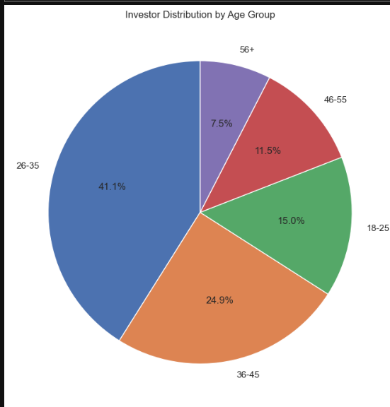

By observing the above pie chart, most investors are distributed in the age group of 26–35.
5.2-SIP amount box plot by age group
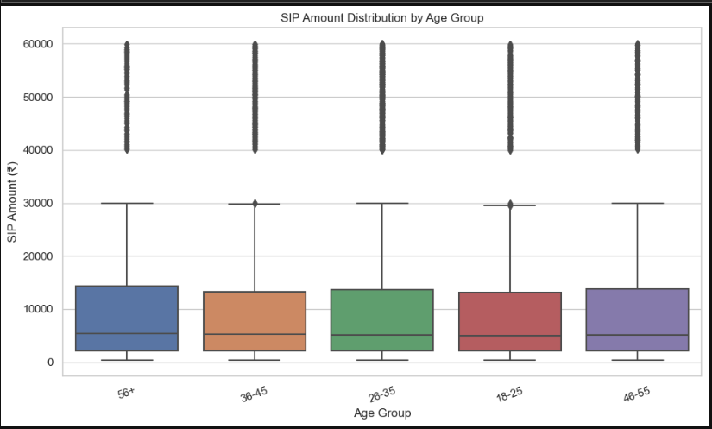
Most investors belong to the 26–35 age group, showing the highest SIP investment activity.

5.3- Gender split
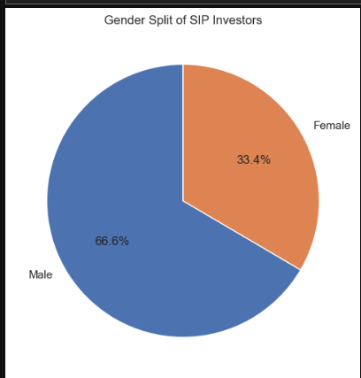

According to the pie chart analysis, males are the highest SIP investors

6. Geographic distribution — horizontal bar chart of SIP amount by state. T30 vs B30 city tier pie chart.
6.1-horizontal bar chart of SIP amount by state
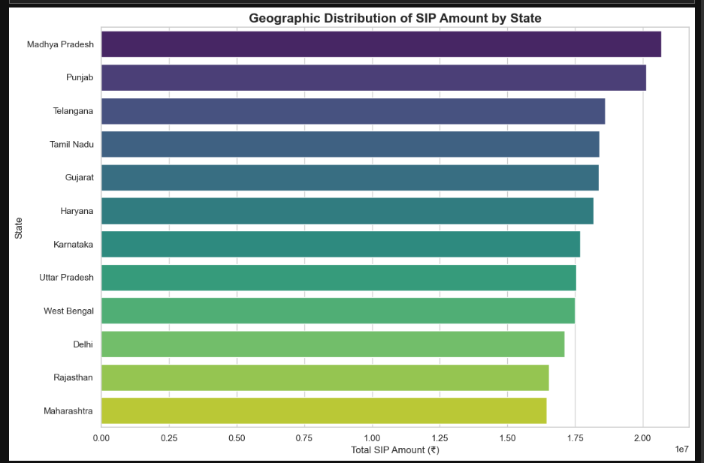
Certain states contributed significantly higher SIP investment amounts than others, highlighting regional concentration in mutual fund investments.
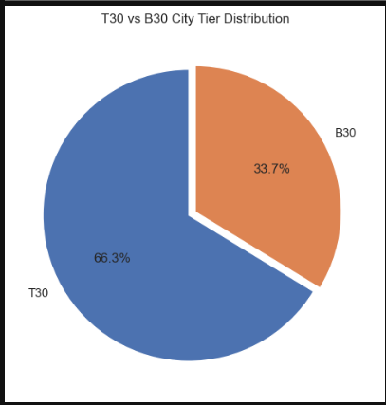
6.2- T30 vs B30 city tier pie chart.

The pie chart shows that T30 cities account for 66.3% of the total distribution, while B30 cities make up 33.7%, indicating that SIP investments are more concentrated in T30 cities.

7. Folio count growth — line chart from 13.26 Cr (Jan 2022) to 26.12 Cr (Dec 2025). Mark key milestones.
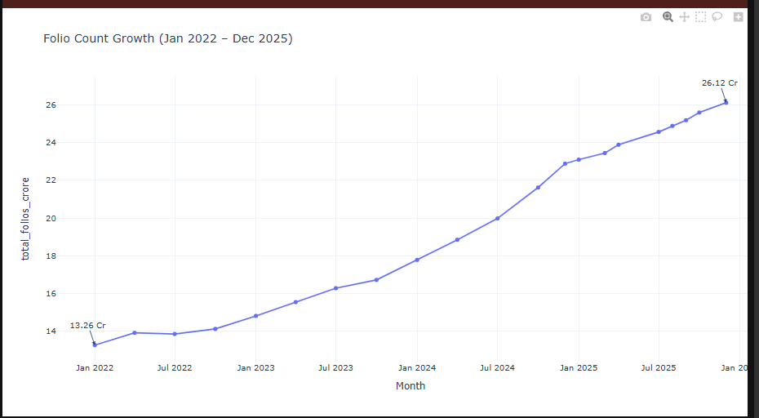
The line graph indicates that the folio count has shown consistent growth from January 2022 to
December 2025, demonstrating a steady year-on-year increase in investor participation.

7.2-Mark key milestones
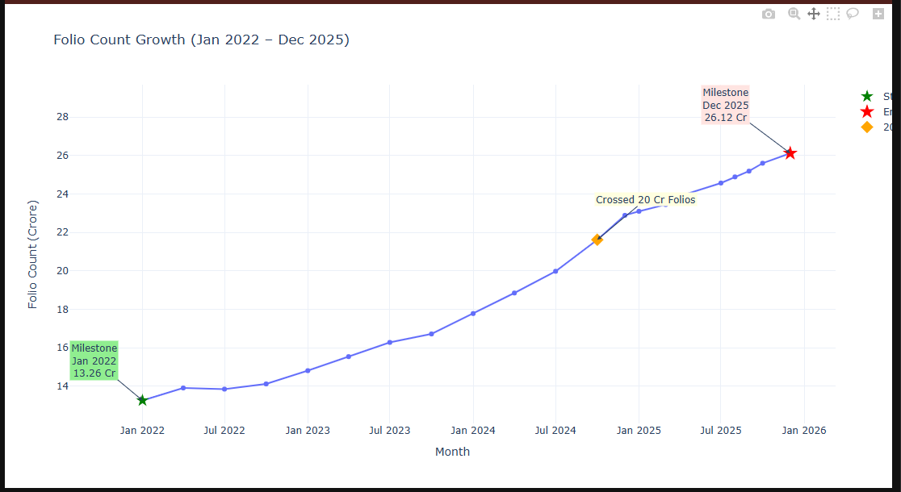
The line graph shows a steady year-on-year rise in folio count from January 2022 (13.26 Cr) to December 2025 (26.12 Cr), reflecting continuous investor growth
8.NAV return correlation matrix — compute pairwise correlation of daily returns for 10 selected funds. Seaborn heatmap
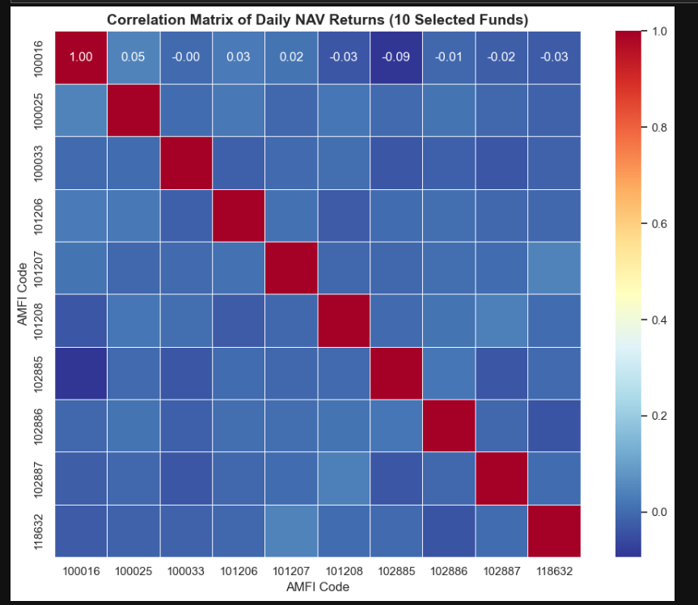
The chart shows that the funds hardly move together — their returns are weakly linked, which makes them good for diversification

9. Sector allocation donut — aggregate sector weights from portfolio_holdings.csv across all equity funds.
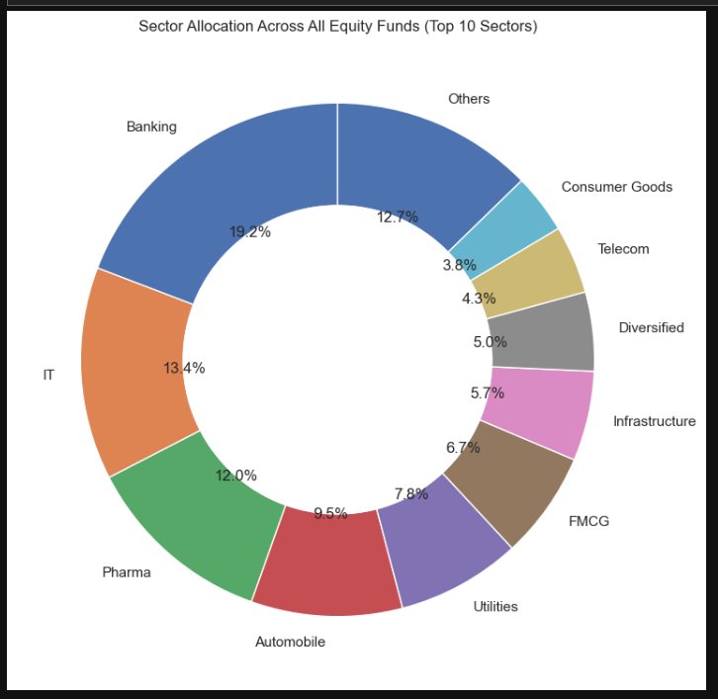
Most equity fund investments are concentrated in Banking, IT, and Pharma sectors, showing investors’ strong preference for stable and growth-oriented industries.

